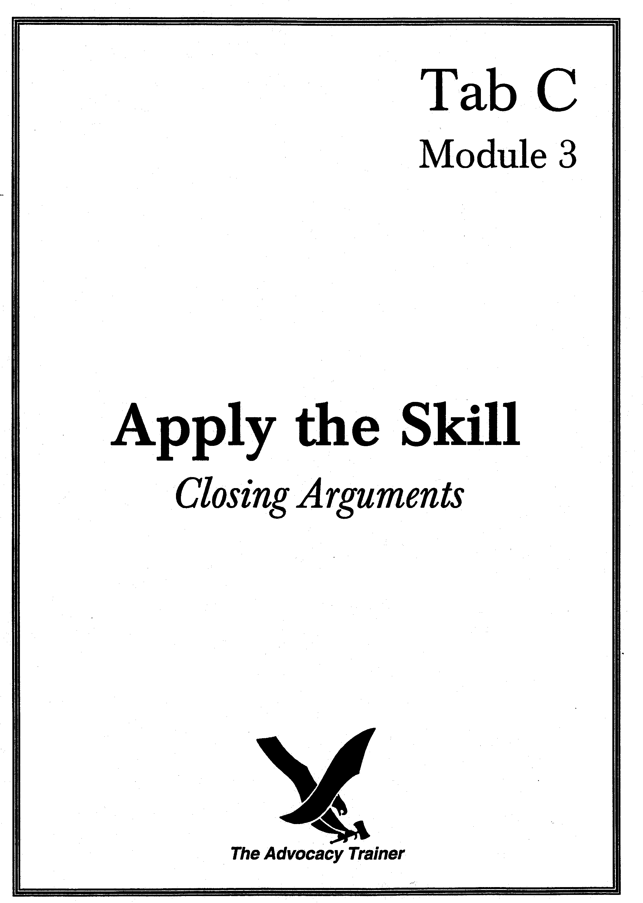
CLOSING ARGUMENTS
SUPERVISOR’S GUIDE

 SKILL OVERVIEW.

Goal. Develop counsel’s ability to prepare and deliver a powerful closing argument.

Training Overview. This module requires two people: you and one of your counsel. When you have more than one counsel, have them sit in a panel area, so your counsel must argue to members while also in the presence of the military judge. Direct your counsel to prepare the argument ahead of time (when you give notice of the training), so that your training session consists solely of counsel’s argument, your critique and then, perhaps, redelivery of the argument or parts of the argument, incorporating your direction. This module does not address sentencing advocacy.

 THE LAW.

Argument by counsel on findings. “In general. After the closing of evidence, trial counsel shall be permitted to open the argument. The defense counsel shall be permitted to reply. Trial counsel shall then be permitted to reply in rebuttal.” RCM 919(b).

Contents of Argument. “Arguments may properly include reasonable comment on the evidence in the case, including inferences to be drawn therefrom, in support of a party’s theory of the case.” RCM 919(b).

There is little law in this area, and objections are rarely sustained unless they involve arguing facts not in evidence, grievously mischaracterizing the evidence, or extremely inflammatory arguments or images.

 the art.

Theory, theme, themela. Help counsel understand these critical concepts, as they often find them theoretical and dense.
- Theory is how the facts mesh with the law to produce a legally defensible verdict.
- Theme is the most personal and specific aspects of the case (e.g., accused is a timebomb or a predator, accused is a victim of misidentification, vindictive charge of rape, etc.), the aspects of the case that provide the moral force, the who and why that bring your case to life. Why the verdict is morally desirable – making members comfortable with the choice you are advocating.
- Themela is the still more personalized application of a broad theme to this case (e.g., accused harbored a grudge that resulted in his exploding in this instance; accused is a misunderstood, sensitive soul whose actions reflect an unbalanced but good faith desire to right wrongs). Themela marries logic and the elements to emotion or human nature. Counsel should be able to express their theme in a sentence or so, and it should permeate the argument.

Start strong and end strong. This is classic primacy and recency; people remember what they hear first and last. You want to think hard about the first words out of your mouth as well as your closing lines; an ideal statement should appear spontaneous, but shouldn’t actually be.

Humanize the victim or accused. Part of this is terminology, but it should be more than calling the accused by name, if defense counsel or “the accused” if the government (in fact using full rank is sometimes effective for a TC when emphasizing loss of respect). Counsel should paint pictures of victims or accused soldiers by placing them in scenarios or filling in human details that bring them to life; members will remember these facts and it will help counsel get past the temptation to look at the case as (merely) a contest between lawyers.

Argue! The only purpose in getting out of your chair is to persuade the jury to do something: acquit or convict. Every sentence in the argument, every word choice, every decision of what evidence to highlight, ignore, or explain away, every decision of what to talk about in what sequence should move the panel or judge toward that end. Mauet writes that “argument is not a summation,” that is, it’s not so much the time to “tell them what you told them” as it is to hammer home relentlessly how what you showed them (or opponent failed to show) supports your theory of the case.

How do you know you’re arguing? Encourage counsel to:
- Draw and argue conclusions and inferences. The evidence supports any number of interpretations, from the solid and plausible, to the fanciful. Argue yours.
- Comment on witness demeanor. Don’t underestimate the extent to which judgments about credibility are based on effect, how a witness looks and sounds. Pounce on this. (Footnote to counsel: illustrates an inherent limitation of stipulations of testimony.)
- Apply law (including instructions) to the facts. It’s not appellate argument but neither is it a plebiscite. Assume that panels try to analyze the case in light of the law; make it easier for them.
- Refute the opponent’s case. Most critical for the defense in its lone closing argument. Skilled trial counsel will often give a “minimalist” closing argument and save their strongest arguments for rebuttal, the one argument of the day to which the defense does not get to reply.

Burdens. The government must not in any sense state or imply that the defense has the burden to do anything (i.e., put on a defense or testify) or improperly call attention to the defense’s exercise of its rights (e.g., right not to talk to commanders or law enforcement). All the more reason to steer clear of the law (normally, with obvious exceptions of sophisticated affirmative defenses and some judge alone trials) and address the facts on which the panel will be focused. Government should gladly accept the burden as a matter of course.

 PRACTICE POINTERS.
Discuss the following points with counsel.

- Trust the panel. Don’t rehash the evidence (“Agent Charles told you…”). Avoid clichés, or use them with a novel twist. The first word of counsel’s argument should directly and powerfully relate to why the accused should be convicted or acquitted.

- Enthusiasm. Does not necessarily mean cheerleading or table pounding. It does mean caring – or seeming to care – strongly about the case and the position you are advocating. Reflected a number of ways, most obviously in inflection and word choice, but also a soldier’s command of the courtroom, a trial counsel’s organized presentation of a case, and a defense counsel’s unapologetic advocacy for a fellow soldier.

- Hold the opening against them. Take notes during your opponent’s opening and remind the panel, in your closing, of promises made in the opening that your opponent did not keep.

- Write it first? Some authors suggest that counsel should begin preparation of their cases by writing their closing arguments. Consider the practice. The closing is the total packaging of the case theme – facts of this case integrated with law, persuasively argued so that a panel or judge makes the decision advocated by counsel. Assembly of the rest of the case – who to call, in what order, what to ask them, what cross to plan – hinges on the theme that will be presented in the opening statement but argued in the closing.

- Wield exhibits. If they’re worth admitting into evidence, they’re worth reinforcing at every opportunity, because people learn best through multiple senses.

- No personal opinions. “I think the accused…” Of course you think: you’re the prosecutor or the defense counsel. You need not even (and should not) say “the defense believes” or “it is the government position.” Sometimes this is spillover from the opening statement, after which counsel may become too cautious about arguing. Assertions in a closing need no preface or attribution; it is total advocacy, counsel’s plea for a verdict based on counsel’s version of the evidence (his theme).
- No inside baseball. Don’t talk about the function of a closing argument, how it is not evidence, etc. It sounds defensive, panels don’t care, it invites them to ignore you, and the judge tells them anyway. This is not to say that you should not mention legal concepts to a panel. When a case turns on a significant legal point (e.g., knowing use of marijuana, consent in a rape case, divestiture in a disrespect case), expect a panel to understand your well-planned, lucid explanation of the law. The government does get to go first and last, and passing reference is OK so long as it does not risk the appearance of sniveling.

- Highlight your strengths. The other side will hammer at your weaknesses; when you have a particularly strong part to your case (extremely sympathetic victim, registered source with checkered past), you can hardly over-sell it. But…

- Compensate for your weaknesses. You should account for significant weaknesses. Not every weakness. Some appear more important to you and some will slip by your opponent. The obvious weaknesses to your case – perhaps compromises made by your victim, lab errors, admissions by your client – need to be addressed by you, but do so with a plan. It does show your candor and suggests a sense of balance but you should couple the admission with a compensating fact that diminishes the damage and gives the panel an “out” or better context in which to place the weakness.

- Incorporate instructions. Counsel should know all or virtually all of the instructions the judge will use. There is no need to preface them with “the judge will instruct you” because (a) he might not, and may choose this opportunity to point that out, and (b) better that you steal the language of the instruction, so that when the judge utters it, he appears to be affirming your wisdom.

- Inferences and matters not in evidence. Counsel have liberal rein to argue inferences from the evidence. Counsel must be careful, however, only to rely on evidence properly admitted. The extra burden on defense counsel is to abide by the ethical rule that forbids calling the attention of the panel to the absence of evidence when in fact that evidence was suppressed.

- Waive closing? Don’t even think about it. No doubt there is the rare case – a paper AWOL case to a judge alone – in which it is conceivable, but waiver often reflects undue confidence and can be interpreted negatively. Defense waiver of closing argument will be scrutinized with an eye toward ineffective assistance of counsel. Government waiver does not ensure the chance to argue in rebuttal: if the defense also waives, the government will not be permitted a rebuttal because there is no defense argument to rebut.

 SKILL DRILLS.

Goal: Train counsel to deliver a persuasive closing argument.

Conduct the drills.

Preparation. Give notice of time and date of training with guidance to prepare a closing argument from a previous or upcoming case. Or provide them some facts or a short case file and direct them to prepare a closing argument.

Execution.

Choose an aspect, or several aspects, of a closing argument and tell counsel to prepare their closing, or segment of closing argument, with special emphasis on the skills required. You can still have them deliver an entire closing, but narrow your critique to an aspect below, advising counsel that you simply are not evaluating for other aspects at this time. Have them prepare a closing for a future case, but you can also have them give a closing for a case already tried or for simple facts you make up. For example, deliver a closing (or segment) that focuses on:
- Theme: all parts of the statement relate to a central theme.
- Organization: why certain parts of the statement appear in the sequences they do; transitions.
- Primacy and recency (start and end strong).
- Humanizing the accused or victims.
- Language: precise and appropriate language (avoid jargon, use military and technical terms correctly), use strong impact words, avoid verbosity.
- Use of exhibits.
- Defuse weaknesses.
- Incorporating anticipated instructions.
- Delivery mechanics.
- Arguing.
- Refutation.

There is no “school solution” to this exercise, because counsel should give closing arguments on concluded or upcoming trials, unless you provide scenarios to them. Stop them during their statements as they deliver information that is objectionable, unclear or misleading, but concentrate on the aspect of closing arguments that is the focus of this drill and on which you gave counsel notice to prepare. This also enables you to conduct many closing argument drills, because aspects of the same argument can be given more than one time until the teaching value is exhausted.

Play the opponent. For defense counsel, give them a sense of what the government argued (better still, deliver the argument yourself), then have the defense deliver the closing immediately (as in court), incorporating rebuttal of the government’s argument into their prepared closing. For trial counsel, give them a sense of how the defense would respond to their closing (again, best example is to deliver that closing yourself) and then require your counsel to immediately deliver a rebuttal.

“Skull Session”: Starting and stopping. Pull a closing from a record of trial. Photocopy it and have counsel draw a line at the point at which the argument starts to have anything to do with the case at hand. Frequently counsel “wheel spin” through a paragraph or two or three in which they issue generalities about what a closing argument is, who has what burden, etc. Now look at the first sentence that relates to this case or client. Start with that and make it as punchy and engaging as possible. When counsel begin their arguments, discourage them from generic beginnings; such blandishments quickly bore a panel that often then misses the real start to the argument when you start to argue your case.

End strong as well. Draw a line at the end of closing arguments when counsel diverge from the case at hand and go into closing generalities about the burden, listening to the judge, etc. Look at the last line during which counsel actually talked about the case. Now make that punchier and more dramatic. Then stop.

 Summarize the Main Teaching Points.
- Argue.
- Argue a coherent theme.
- Start and end strong.
- Use powerful, persuasive language.
- Forceful but credible theory (acknowledge important weaknesses).
- Refute significant portions of opponent’s case.

 REFERENCES.

Thomas A. Mauet, Trial Techniques chapt. 8 (4th ed. 1996).

Trial Counsel Assistance Program Memo #55 (Advocacy Supplement) (July 1990).

Thomas A. Mauet and Warren Wolfson, Materials in Trial Advocacy (3d ed. 1994).

Michael Marcus, Trial Preparation for Prosecutors chapt. 19 (1989).
closing arguments
counsel handout

 training overview.

Introduction. The next trial advocacy training session, scheduled on _______________, from ______ to ______ hours, will focus on closing arguments. The training will be conducted in two parts. First, I will lead a discussion about the various techniques necessary for a powerful closing argument. After a short break, we will reconvene for the second part of the training, during which counsel will deliver a closing argument, or part of a closing argument.

Preparation. Counsel must bring their Manual for Courts-Martial to this trial advocacy training session. Counsel must also be prepared to deliver a closing argument from an upcoming case, a prior case, or from a fictitious scenario I provide. Finally, counsel will review, and be prepared to discuss, the closing argument skills listed in part II.

 keys to success.

Theory and theme.

Start strong and end strong. 

Start with a punch - counsel’s first words should directly and powerfully relate to why the accused should be convicted or acquitted.

End forcefully - no closing generalities.

Argue! 

Comment on witness demeanor. 

Do not rehash the evidence - argue inferences from the evidence.

Incorporate instructions.

Humanize the victim or accused.

Language.

Use strong impact words.

Avoid verbosity and legalese.

Use precise language.

 references for further study.

Thomas A. Mauet, Trial Techniques chapt. 8 (4th ed. 1996).

Trial Counsel Assistance Program Memo #55 (Advocacy Supplement) (July 1990).

Thomas A. Mauet and Warren Wolfson, Materials in Trial Advocacy (3d ed. 1994).

Michael Marcus, Trial Preparation for Prosecutors chapt. 1 (1989).

